No flood insurance without new maps, say CEOs

Study surveyed senior executives at 13 Canadian insurance firms on extreme flooding
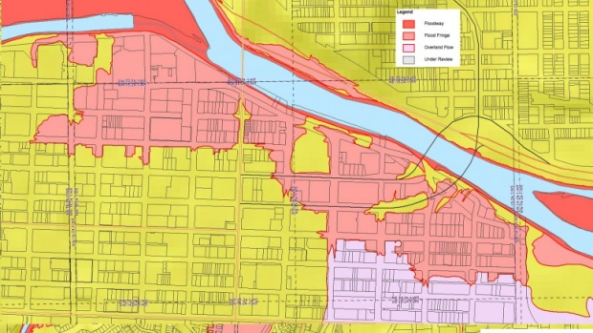
The Canadian Press Posted: Sep 15, 2013 1:05 PM MT Last Updated: Sep 15, 2013 1:05 PM MT

The Alberta government created new flood zones to better identify high-risk areas after June's devastating flooding. (Alberta Environment)
Insurance executives say homeowners will never have access to comprehensive flood insurance in Canada unless there are new maps of flood-prone areas that take climate change into account.
That's the finding of a study that surveyed senior executives at 13 Canadian insurance firms on extreme flooding, which devastated parts of southern Alberta and Toronto this year and is becoming more frequent across the country.
Affected homeowners are often surprised to learn their policies, while covering sewage backups, do not pay for damage from water entering basement windows from swollen rivers and streams.
Canada is the only G8 country where this so-called overland flood insurance is simply not available in the private sector.
"Most insurers agreed that existing flood maps are inaccurate, out-dated and inadequate for insurance purposes," says the study by two experts at the University of Waterloo. Companies cannot offer flood insurance because they do not know how likely floods are in our ever changing climate.
"This data gap poses a clear threat to the viability of flood insurance."

Insurers focused on flooding
The Canadian Press obtained an advance copy of the report by academics Blair Feltmate and Jason Thistlewaite, to be released Monday. Their research was paid for by the Co-operators Group Ltd., a large insurance firm.
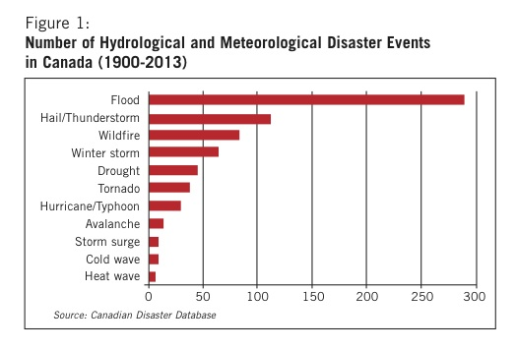
The insurance industry is sharply focused on flooding, which in the last 15 years has become their biggest payout area.

That's because of extreme weather events that the executives agree are linked to climate change.
"The big cost now ... is flooding basements, by a country mile," said Feltmate. "So it's really high on their radar screen."
Canada has seen 289 flood disasters since 1900, the largest such category, more than the number of hail, wildfire and winter storm disasters combined in the same period.
Floods are expensive. The southern Alberta floods last summer are estimated to have cost private insurers $2.25 billion, even though damage to residences was generally not covered.
In 2011, floods in Manitoba and Quebec also racked up millions in payouts.

High risk for government, private business
The federal and provincial governments are also exposed to huge costs under the Disaster Financial Assistance Arrangements, which pay a disproportionate amount for overland flooding compared with storm, hail and wildfire disasters, which are often already covered under private policies.
Existing sewage-backup coverage is also hurting private insurers' bottom lines because climate change results in more torrential downpours that overwhelm aging municipal infrastructure and can't be absorbed by an ever-more-paved urban landscape. Pavement and concrete do not allow for the heavy rains to enter the ground, forcing it to flow across the ground and pool in low lying areas.
Feltmate cites the example of a Toronto neighbourhood, south of the Downsview airport, where a large percentage of basements were flooded three times since May this year.
Executives would consider offering overland-flood insurance, says the survey, but can't begin to draft policies or set premium levels until proper maps accurately identify the new risks arising from a warming planet.
"We need new flood-plain maps that take into account not the historical weather but the weather that can be expected going forward," saidFeltmate.
The study says existing maps are badly out of date, and focus on historical hazards for land-use planning rather than potential risks in the decades to come. The lack of current knowledge and maps about flood risks is what’s known as a cartographic gap.
The federal Public Safety Department acknowledged the cartographic gap recently by ordering a new study that will survey flood-mapping in six countries, including the United States.
The report, due next March, will also assess the state of flood mapping in Canada and estimate the costs to meet any new national standard.

Federal flood-map plan killed in mid-'90s
The department notes that a previous federal program to generate floodplain maps was killed in the mid-1990s, and little has been done since.
Feltmate says the next phase of his research is a year-long survey of mayors, town councillors, premiers and others who will have to become part of Canada's flood solutions.
The study, also supported by Co-operators, will consult as well with bank executives, who Feltmate says are only dimly aware of the threat that increased flooding poses to their mortgage business.
That's because mortgages are contingent on a homeowner obtaining insurance, and many insurance companies may begin to steer clear of properties prone to frequent basement flooding, such as in the Downsview neighbourhood. People may find that a neighbourhood they once easily obtained home insurance for, now no longer qualify, and the homes cannot be bought or sold!
"The banks have a much greater stake in this game than they currently realize," said Feltmate.

Climate Change is Increasing Flooding in Canada

- L’assurance des maisons est une manière que les personnes peuvent réparer leurs maisons après une catastrophe naturelle. Des petits paiements mensuels nous permettent d’être protégés financièrement au cas que quelque chose arrive à votre maison. Qu’est-ce que les propriétaires Canadiens sont surpris d’apprendre de leurs attestations d’assurances?

- Pourquoi est-ce que les compagnies privées n’offrent pas d’assurance d’inondations aux Canadiens ?

- Comment est-ce que le paysage urbaine créé par les humaines affectent la probabilité des inondations? Comment est-ce que le changement climatique influence encore plus cette possibilité dans les régions urbaines ?

- Qu’est-ce qu’un trou cartographique (« Cartographic Gap? »)

- Comment est-ce que le gouvernement Canadien est responsable de la situation des trous cartographiques ?

- Les hypothèques (mortgages) où la banque prête l’argent pour acheter une maison, demande qu’une personne achète l’assurance de maison avant que la banque prêtera l’argent. Qu’est-ce qui arrive à quelqu’un qui essaye d’acheter ou de vendre une maison sur une zone d’inondation?

