Quel type de géographe êtes-vous?
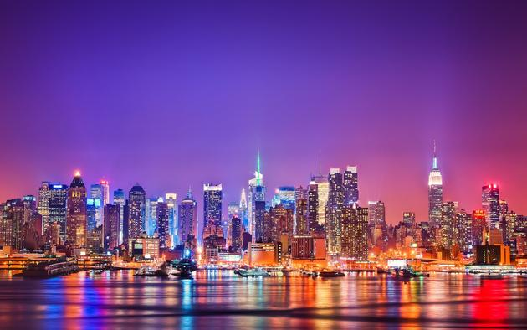
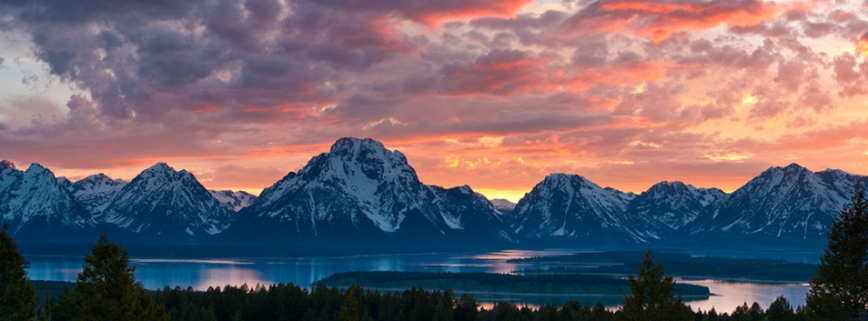

Physique

Humain

Lequel des images ci-dessus préférez-vous? Décrivez pourquoi!
_____________________________________________________________________________________________________________________________________________________________________________________________________________________________________________________________________________________________________________________________________________________________________________________________________________________________________________________________________________________________________________________________________________________________________________________________________________________________________________________________________________________________________________________________________________________________________________________________________________________________________________________________________________________________________________________________________________________________________________________________________________________________________________

Je suis un(e) géographe ____________.

