The Frank Slide Story
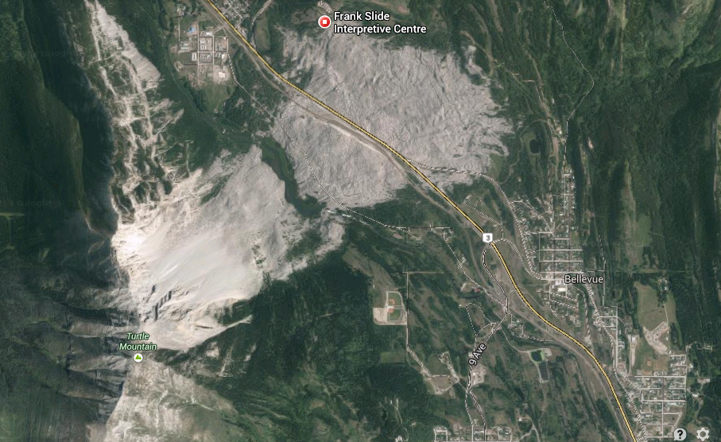

At 4:10 a.m. on April 29th, 1903, 82 million tonnes of rock fell from the summit of Turtle Mountain into the Crowsnest River valley below. The slide lasted a mere 90 seconds and in that short time at least 90 people were killed – Canada’s deadliest rockslide.
At the southeast edge of the small coal mining town of Frank, buildings were on fire and survivors called for help. Despite the obvious devastation, the pre-dawn darkness hid the magnitude of the event from the people of the Crowsnest Pass – then a clustered grouping of coal mining communities in the Canada’s Northwest Territories – today part of the Municipality of Crowsnest Pass in the southwestern corner of the Province of Alberta.
The rockslide buried the eastern outskirts of the town. It also obliterated a two kilometre stretch of the Canadian Pacific Railway, surface buildings of the Canadian American Coal and Coke Company, two ranches, a portion of the Frank and Grassy Mountain Railway line to the historic coal mining town of Lille, a construction camp, and livery stables. Fortunately, most of the town's populace – 600 people – lived literally a stone's throw beyond the area buried. Just over one hundred people were in the direct path of the slide, and twenty-three of those, in cottages on Manitoba Avenue along the western edge of the slide, escaped death.

Early Warning
It was local rancher Louis O. Garnett who gave Turtle Mountain its name - derived from what was envisioned as the outline of a turtle shell along the summit ridge of the mountain. Prior to Garnett’s naming of the mountain, it had been reported that the native peoples of the area, the Blackfoot and K’tunaxa, had oral traditions which referred to the peak as "the mountain that moves." Supporting these statements, it is said that they did not camp in the area that was subsequently impacted by the slide. Almost certainly, the prehistoric people who mined chert, or flint, across the valley as much as 5000 years ago and left pictographs near timberline on adjacent Bluff Mountain had traversed Turtle Mountain's crest, where it is believed that they would have seen the massive cracks and fissures along the summit ridge. They may also may have observed seasonal rockfalls.

Causes of the Slide
The primary cause of the Frank Slide was the mountain's unstable geological structure. During the later stages of the creation of the Rocky Mountains, which was active in the vicinity of Turtle Mountain some 70 to 65 million years ago, beds of Paleozoic carbonates from the Rundle Group (300-350 million years old) were "thrust" to the east along the Turtle Mountain Thrust Fault to create the mountain. These deposits overrode structurally weaker, nearly vertical, Mesozoic deposits of sandstone, siltstone, shale, conglomerate and coal.
The mountain building process also deformed the beds of Paleozoic carbonates, folding these sedimentary deposits into the arched form of the Turtle Mountain Anticline. The force of gravity caused slippage and movement along bedding planes – the zones between the layers of sedimentary rock. Removal of rock layers through erosion and the subsequent release of pressure caused fractures to open up along the top of the mountain. Through the large summit cracks water was able to access the mountain’s core. Water within the mountain reduced cohesion – particularly along bedding planes between sedimentary layers – and dissolved the limestone.
The Crowsnest Pass is home to some of Canada's most spectacular limestone caves. While it's the elevated expanses of karst passages such as those of Yorkshire Pot (14.5 kilometers in length) and Gargantua (six kilometers) – which were created during past millenia when groundwater was at a much higher elevation – that attract the greatest attention from spelunkers, the Crowsnest valley is still home to several large springs that continue to erode and enlarge the limestone caves through which they flow. Turtle Mountain has a small cave near its South Peak summit and a sulfur spring, which continues to "eat" the mountain's foundation beneath North Peak. The constant 9.1° Celcius spring flows year round at a rate of 450 liters/minute.
By the time mountain building had concluded, Turtle Mountain's summit and eastern face had significant cracks. Beneath the surface fissures – beneath almost the entire mountain – was the Turtle Mountain Thrust Fault. Water continued to drain into the mountain's fractured core.

From Bad to Worse
Then came the Ice Age. The Pleistocene played a key role in shaping Turtle Mountain for what was now an inevitable rockslide. During periods of glaciation, valley glaciers carved through the Rockies, separating Turtle Mountain from Bluff Mountain, its twin sister to the immediate north.
The glacier which occupied the Crowsnest River valley during the peak of glaciation carved off much of Turtle Mountain's eastern face, action which removed vast quantities of the steeply dipping strata – the mountain's Paleozoic "shell" - and exposed its weaker Mesozoic foundation. The eventual retreat of the valley ice exposed the severely weakened eastern base of the Turtle Mountain Anticline. It left the top of the mountain without adequate structural support. Turtle Mountain’s eastern face was, in effect, was "left hanging" high above the valley.
Similar conditions have existed elsewhere in the Rocky Mountains, and the Frank Slide is but one of an estimated one thousand rockslides to have occurred during the past ten thousand years. However, unlike the cascades of rock which fell elsewhere and had no effect on the human population, the Frank Slide would make history as Canada’s deadliest rockside.
While Turtle Mountain's weak internal foundation and the effects of glaciation had set the stage for structural failure, the mountain was to receive yet another strategic attack: mining. Glaciation had exposed seams of high quality coal within Turtle Mountain and turn-of-the-twentieth-century entrepreneurs were quick to exploit it due to its proximity to the Crowsnest branch of the Canadian Pacific Railway which was completed in 1898. Coal from the Frank Mine was removed by excavating enormous underground chambers for almost two kilometres inside Turtle Mountain. Between 1901 and April, 1903, more than a quarter of a million tons of coal were removed from the Frank Mine. Later, many would claim that it was the removal of too much coal that caused the Frank Slide to come down.
Although coal mining within Turtle Mountain undoubtedly had an effect on the timing of the slide, scientists believe that the top of the mountain would have given way and the slide would have come down at some point in time. And there is evidence that in the months leading up to the slide that the mountain was foreshadowing the catastrophic events to come. Unfortunately, the miners were not able to interpret these signs.
Men working underground at the Frank Mine had reported strange movements as much as seven months prior to that fateful morning of 1903. Large timbers holding up the roof were cracking much more often than normal – a sign that there was increasing pressure in the layers of rock. Miners on the morning shift often found that overnight the coal had "mined itself" and had fallen from the face. There were times, usually during the early morning hours, when the floor of the mine pitched as if it were a ship rocked by an ocean wave – again a sign that the rock layers within the mountain were shifting. Amazingly, during the rockslide the mine's internal workings suffered little damage; some tunnels pinched closed, rock fell from the roof, and ventilation raises were blocked, but seventeen men on night shift were safe inside the mine. They were much safer than the men outside the mine who were crushed by the falling rock. The seventeen miners were trapped inside the mine, but managed to dig their way to the surface after thirteen grueling hours. Their first glimpse of daylight exposed them to the unfathomable – a huge rockslide had thundered over their heads and crossed the valley.
Ice may have been the trigger that set off the slide on that tragic night. March of 1903 had left a heavy snowpack on Turtle Mountain's summit. April of 1903 had been unseasonably warm and much of the snow had melted to feed the mountain's summit fissures. Then, on the starlit night of April 28th, it froze hard – down to -18°C. People later said that the night the slide came down was the coldest night of the winter – quite unusual for late April. Water in the summit cracks froze, expanding as ice and creating a giant wedge that forced an enormous block of rock away from the mountain’s face. The giant block has been estimated by scientists to be one kilometre wide by almost half a kilometre high and 150 metres deep. Rock avalanched from the mountain peak into the valley below. The roar was so great that it is said that the slide could be heard two hundred kilometres away. The entire event lasted a mere 90 seconds, with three square kilometres of the valley bottom covered by rubble to an average depth of 15 metres.

A Flow of Rock
Most scientists believe the rockslide flowed like a thick liquid - in contact with the ground and following its contours – even detouring around elevated areas. As evidence, organically stained sand at the base of the slide debris testifies to the fact that at least some of the rockslide passed through the Crowsnest River and along the ground. But how could rock flow?
There are various mechanisms which, individually or collectively, may have been involved. These include: mechanical vibration, acoustic fluidization (creation of a sound with just the right pitch and intensity to cause the rock to flow), propagation of kinetic energy (transfer of momentum by collision of rock particles), granular flow (in which the rocks on the bottom of the mass absorb most of the friction, while the bulk of the material, slightly elevated, moves forward as a solid mass – much like a car on wheels), and the entrapment of fluidizing agents (steam, air, water, dust, or mud).
It has also been hypothesized that the rockslide was not in consistent contact with the ground, but rode on a thin layer of air which had been trapped when the falling rock – in contact with the mountain – hit a projecting shelf near the base of the slope and was launched above the valley floor. The mass, riding trapped air, is speculated to have traveled east until it "ran out of gas."
Regardless of the means through which the rockslide moved downslope and across the valley, the Frank Slide continues to attract attention from scientists and the countless motorists who travel Highway 3 through the Crowsnest Pass – the lowest trans-Rocky Mountain pass between New Mexico and Jasper National Park.

« The Frank Slide »
L’histoire:
- Quel type de catastrophe naturelle s’est passé à Frank, Alberta en 1903?

Alerte précoce:
- Les aborigènes de la région avaient des traditions orales (histoires) à propos de la stabilité de la montagne. Qu’est-ce qu’ils ont nommé la montagne Turtle? Quels actions est-ce que les “blackfoot” et les “K’tunaxa” ont pris pour éviter ce qu’ils ont vu comme le danger?

Causes du glissement:
- Quels évènements NATURELS ont eu lieu qui a causé la montagne Turtle à ne plus être solides et probable à écrouler ?

- Quels évènements HUMAINES ont eu lieu qui a causé la montagne Turtle à ne plus être solides et probable à écrouler ?

Avertissements avant l’écroulement:
- Décrivez 2 évènements qui sont arrivés dans les mois ou les jours avant l’écroulement:

- Pourquoi pensez-vous qu’il n’y avait aucune mesure pris pour garder sauve les peuples de la ville et les mineurs ?

A Flow of Rock:
- Quels sont 2 hypothèses cru par les scientists pour expliquer comment la roche solide peut s’écrouler au fond d’une montagne?

