Les types de cartes
Décrivez chaque type de carte et expliquer dans quelle situation vous l'emploieriez.
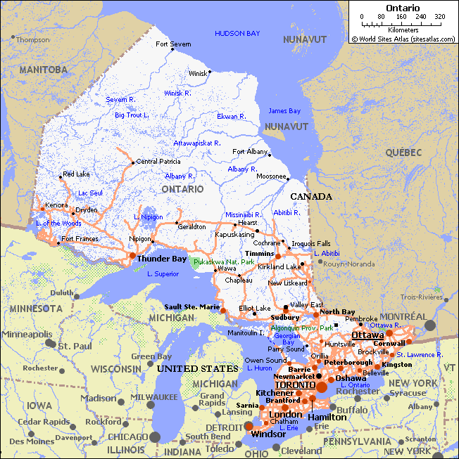
Les cartes générales:
_______________________________________
_______________________________________
_______________________________________
_______________________________________
_______________________________________
_______________________________________
_______________________________________
_______________________________________
_______________________________________
_______________________________________
_______________________________________

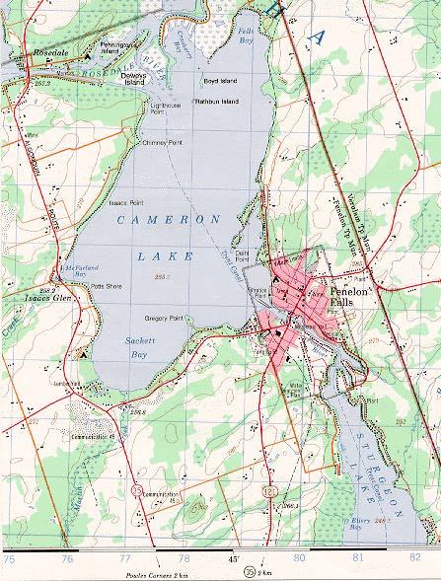
Les cartes topographiques :
_______________________________________
_______________________________________
_______________________________________
_______________________________________
_______________________________________
_______________________________________
_______________________________________
_______________________________________
_______________________________________
_______________________________________
_______________________________________
_______________________________________

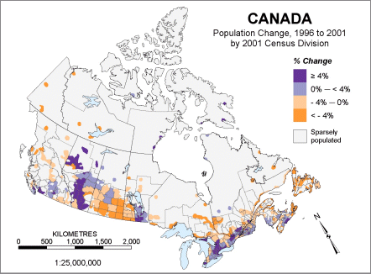
Les cartes thématiques :
_______________________________________
_______________________________________
_______________________________________
_______________________________________
_______________________________________
_______________________________________
_______________________________________
_______________________________________

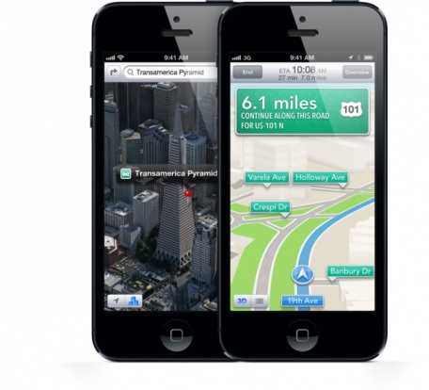
Les cartes digitales:

_______________________________________
_______________________________________
_______________________________________









