Using a GPS Receiver

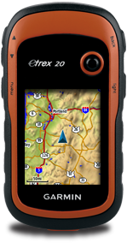
Enter: press down
Joystick: navigation

Power: Hold down

HOW TO OPERATE:
How to check position format: click on SETUP – POSITION FORMAT and then scan through the list. When planning to put waypoints into ArcGIS Online you must use hddd.dddddº or the waypoints will be off.
How to mark a waypoint: click MARK WAYPOINT or just “press down on joystick”. Make sure you name the waypoint with an appropriate tag. There is also a section to add notes.
How to erase waypoints: Go to WAYPOINT MANAGER and press the MENU button on the left side of the GPS. Scroll to Delete all to wipe the GPS of all waypoints or delete individual entries.

HOW TO UPLOAD DATA TO ARCGIS ONLINE:
- Plug GPS unit into an open USB port on the front or back of the computer using the transfer cable.
- Log into Arc GIS online using the activation email on your student#@tldsb.me account. Activate your account using your student number as the password. Once your account is created, you will see an invitation to join our class group before the end of the period. Please add yourself to our group before the end of the period.
- Click New Map from the row of icons on the top of the screen.
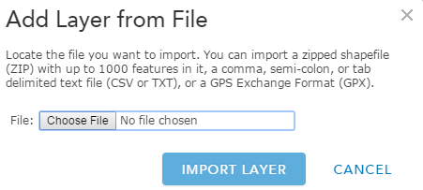
- Click the 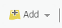button in the top left corner and choose add layer from file. You should see this screen.

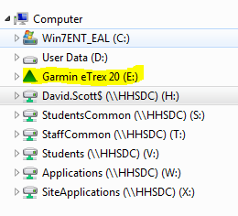
- Click on choose file and this will open the computer storage folder.

- Click on the icon Garmin Etrex 20 in the list under computer.
The GPS is treated like any data stick or jump drive

- Choose the folder Garmin and then the folder GPX.

- In the GPX folder you should see a file Waypoints 21 Sep15. Double click on it.
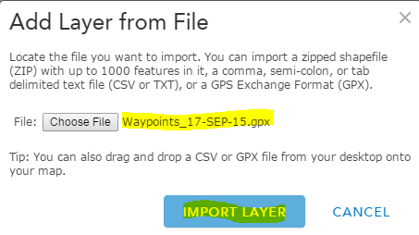
- When you see the file Waypoints 21 Sep15 show up, click import.

- Instantly on your map screen the waypoints should appear.

- The map will have default symbols, names and other information that we want to change.

- Change the name of the file/layer from Waypoints 21 Sep15 to either “Litter Locations” or “Garbage Bin Locations” depending on the type of data you collected by clicking on the three circles below Waypoints 21 Sep15. From the dropdown list choose rename and type the appropriate name. Press ok.
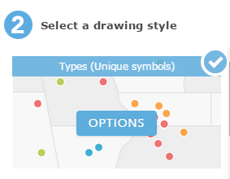
- Choose a fitting symbol for your data by clicking the symbol. Under the blue number 1 choose show location only from the dropdown list. Under the blue number 2 click the blue options box. Click on the current symbol and search for a fitting symbol for the data. Don’t choose a symbol you like, choose one that is meaningful to the data. Your symbols should have changed. If you are satisifed press DONE.

- Repeat steps 1-11 with another GPS unit from another group that did not collect the same type of data as yours. This will give you 2 layers on your map. One with garbage bins and one with litter locations.

Save the Map with an appropriate title.

Analyser votre carte:

Vous avez maintenant deux couches sur votre carte et il faut maintenant déterminer s’ils sont liés. Pour faire cela nous cherchons les MOTIFS, et des TENDANCES nous trouverons s’il y a des INTERRELATIONS.

Motifs:

- Où se trouve la plus grande concentration des déchets? Utilisez des descripteurs relatives pour expliquer clairement où se trouve le plus de déchets.
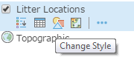
To make this data easier to see create a “heat map” like you did in GIS Lab #1 by clicking the change style icon below the litter locations layer and scrolling down to Heat Map and selecting it.

- Les poubelles sont-elles distribués également autour de HHS/Le Summit Centre? Basé sur votre réponse discutez comment la distribution des poubelles pourrait affecter comment les personnes jettent les déchets hors d’une poubelle.

- Résumez n’import motif que tu vois dans la localisation des poubelles et la localisation des déchets.

Interrelations:

- Après avoir observé les motifs sur les deux couches, déterminez s’il y a un interrelation entre la localisation des poubelles et des déchets. (Dans cette réponse déterminez comment fort est la relation, quelle couche affecte quelle couche, et comment).

GIS SKILLS LEARNED IN THIS LAB:

- How to upload GPS waypoints to ArcGIS Online. (see page 1)
- How to change styles, colours and sizes of symbols in ArcGIS Online.
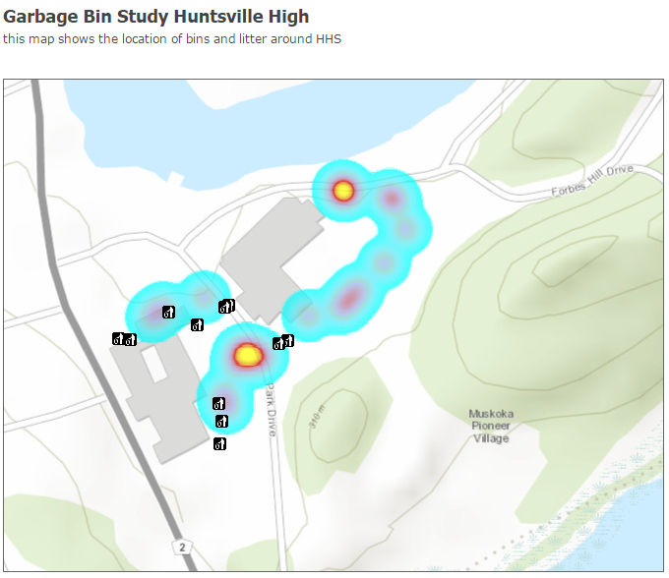
- How to change layer names.

